MEMORANDUM

275 Seventh Avenue New York, NY 10001 USA

Telephone: (212)-779-7700 Fax: (212)-779-7785 www.srbi.com

TO: Jennifer Marlon, Geoff Feinberg,
COMPANY: The Yale Program on Climate Change Communication, Yale School of Forestry & Environmental Studies
FROM: Sujata Pal, Andrew Burkey, Charles DiSogra
DATE: 12/30/2014
RE: Coastal Connecticut Residents Survey

Abt SRBI has supported Yale University in this survey effort to collect data from residents of the coastal Connecticut storm evacuation zones as defined by the Army Corp of Engineers. The survey was supported by NOAA Seagrant and collected data about residents’ knowledge of and attitude towards extreme weather events such as hurricanes, experience with such weather events while residing in coastal Connecticut and key demographic and socio-economic indicators. Abt SRBI supported Yale University in developing the sample design, questionnaire design, data collection, processing, and weighting and segmentation analysis. This memo summarizes the sample design, data collection, data processing and weighting activities.

Sample Design
The population for this study was defined as Connecticut residents who live in the coastal evacuation zones. Abt SRBI received maps delineating evacuation zones A and B from Yale University. The GIS team at Abt SRBI used these maps to identify census block groups that overlap with the hurricane evacuation zones (Figure 1).

An address based sample design was used to conduct the survey. Using the list of block groups identified by GIS processing, Abt SRBI acquired a random address based sample of residences that are located in these block groups. Block groups which had 20% or more land area within either of the evacuation zones were included in the sample. After drawing the sample this way, we geocoded each address to identify those which were located within the hurricane evacuation zones as defined by the maps. The final sample included addresses located within the boundaries of either of the evacuation zones. The sample was stratified by two strata – evacuation zone A and evacuation zone B. A random sample of1800 addresses were selected for each stratum for a total sample size of 3600 addresses.

Figure 1: Census Block Groups overlapping Coastal Connecticut Hurricane Evacuation Zones

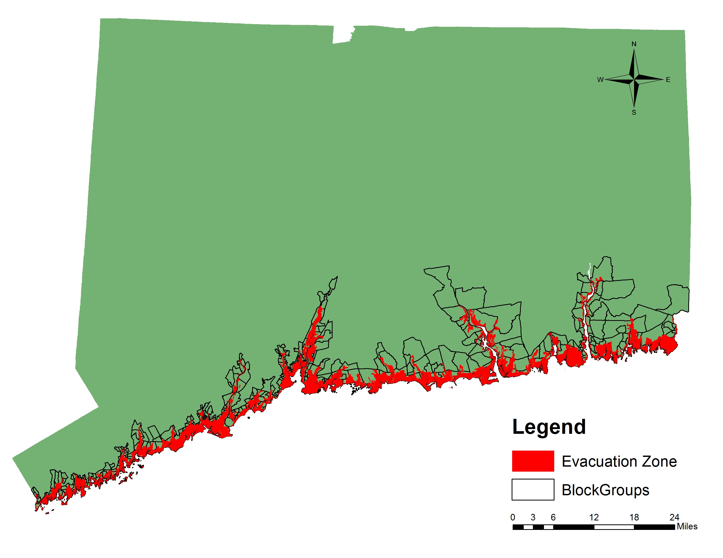

Data Collection
The survey was conducted using a self-administered mail questionnaire. The mailing protocol included four contacts – a pre-notification postcard, a survey packet mailed a week after and a reminder/ thank you postcard mailed two weeks after the first contact. A second follow-up survey packet was mailed to non-respondents two weeks after the reminder notification. All mail was sent using first class mail. The survey packets included a postage paid business reply envelope and a cover letter explaining the purpose of the study. A pre-paid cash incentive of $2.00 was included with the first survey mailing. The pre-alert and reminder postcards included Spanish language text for households where a language barrier exists. Respondents who preferred a Spanish language survey were instructed to call a toll free number and leave a message requesting the survey in Spanish.

Table 1. Schedule of Data Collection Activities

Mail Contact | Date
Pre Notification Postcard | 9/16/2014
First Survey Packet | 9/23/2014
Reminder/Thank You Postcard | 9/30/2014
Second Survey Packet | 10/14/2014

Abt SRBI developed detailed protocols for data editing and entry in consultation with the clients. Issues such as out of range responses and multiple responses were identified and documented by data entry staff at the beginning of the data entry process. Protocols regarding how to resolve these issues were developed with feedback from the clients and these protocols were observed through-out the data entry process.

Weighting Summary
To account for item missing data, missing values in the weighting variables were imputed using modal imputation within each of inundation zone. The weights then aligned the survey sample to population benchmarks for the study’s geographic area. The weighting was conducted using an operation known as raking ratio estimation, or “raking.” Raking is used to reduce biases from nonresponse and non-coverage in sample surveys. The raking procedure aligns sample demographics to population benchmarks for householder race/ethnicity, home ownership, household size, household income, and the presence of children age 17 or younger in the home.

All of the population benchmarks, with the exception of household income, were obtained from the 2010 Census for all households located in block groups selected for the study. The household income benchmark was obtained from the 2009-2013 American Community survey in the same selected block groups. Since inundation zones do not align with any Census geography, each Census block group benchmark was adjusted by the proportion of households living in the inundation zone. For example, if 40% of the households in a block group are in Zone A, the benchmark for that block group was adjusted by 40% for inclusion in the Zone A target.

The final weight variables contain valid weight values only for respondents who completed the entire survey. Final_wgt_pop is scaled to sum to the estimated total number of households in the selected block groups (N=124,389). Final_wgt_samp is scaled to sum to the total number of completed interviews (n=1130). For within inundation zone analysis, Final_wgt_zone_A and Final_wgt_zone_B have been provided scaled to sum to the total number of completed interviews in that zone (A: n=684; B: n=446). For between inundation zone analysis, Final_wgt_pop or Final_wgt_samp should be used.

A summary of the weights is reported in Table 1 below. Table 1 also shows the survey’s design effect of 1.46. The design effect (Deff) is the ratio of the variance derived from a survey sample design to the variance that would be obtained from a simple random sample. We estimate the design effect (Deff) based on the study sample weights as the ratio of the average of the squared weights to the average of the weights. The formula for that estimation is:
Deff= [(Σ w_{i}²)/n]/ [(Σ w_{i})/n]
where n equals sample size. When using weights that are scaled to the sample size (as was done with these data), this formula gets simplified to just the ratio of the sum of the squared weights to the sum of the weights:
Deff= Σ w_{i}²/ Σ w_{i} .
Weighting has a statistical impact on the resulting sample size in that the weighted sample, in effect, is reduced. Although the weights will sum to the nominal sample size, in statistical tests where weighted data are used, those tests need to use what is called the effective sample size for variance calculations. The effective sample size (or effective base) is calculated as n divided by the design effect.
Table 2. Summary of the Weights
Weight Variable |  | Number of cases (n) | Mean weight | Minimum weight | Maximum weight | Standard Deviation | Design effect | Effective n
Final_wgt_pop | 1,130 |  | 110.08 | 25.29 | 637.89 | 74.60 | 1.46 | 774
Final_wgt_samp | 1,130 |  | 1.00 | 0.23 | 5.79 | 0.68 | 1.46 | 774
Final_wgt_zone_A | 684 |  | 1.00 | 0.44 | 5.19 | 0.65 | 1.43 | 480
Final_wgt_zone_B | 446 |  | 1.00 | 0.28 | 4.11 | 0.66 | 1.44 | 310

The use of these weights in statistical analyses ensures that the demographic characteristics of survey respondents closely approximate the demographic characteristics of the study population. As such, they produce a representative estimation of findings generalizable to the study population.

Results and Response Rates
Overall 1130 surveys were completed with a completion rate of 31.3%. Of these, 684 surveys were completed in Zone A (38%) and 446 in Zone B (24.7%). The difference in response rate can be explained by topic salience for respondents who live in Zone A who are more likely to be affected by extreme weather events such as hurricanes. Table 3 below presents full sample dispositions and response rates.

Table 3. Sample Dispositions and Response Rates

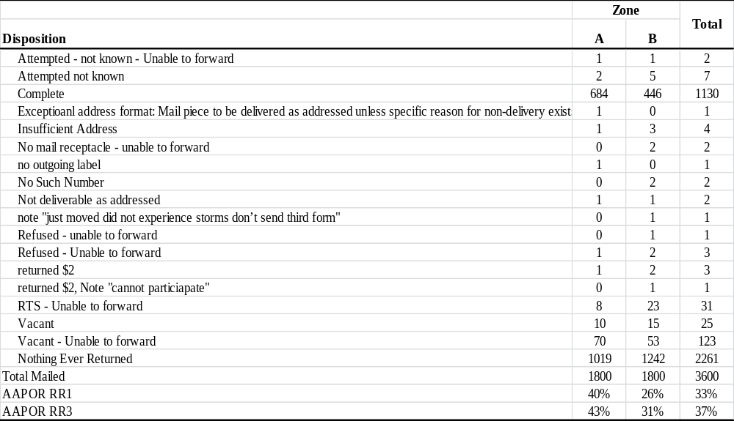

http://cteco.uconn.edu/map_services.htm
For generalized and approximate values of the standard error (se) for a given proportion (p) that incorporate the Deff, the following formula can be used: se(p)= z[Deff(pq/n)]^{1/2} where z = the normalized confidence level (e.g., for 2-tailed 95% confidence, z_{. 975} = 1.96), p is study proportion of interest, q = (1 - p), and n is the sample size. However, variance calculations that take into account complex sample designs may also be used with available statistical packages such as SAS, SPSS or STATA.

